  - III Year B. Tech II Semester Mini Project Work
  - Project- Pulse
  - Branch : CSE(DS) Academic Year : 2024-2025
  - Course Name: Mini Project with Seminar Course Code : GR22A3089
Domain | Healthcare
Project Title | A Comparative Study of ML Models for Tumor Classification
Abstract  This project presents a comparative analysis of machine learning models for tumour classification to improve diagnostic accuracy and reliability. Using the Breast Cancer Wisconsin dataset, models including Logistic Regression, Support Vector Machine (SVM), K-Nearest Neighbours (KNN), Decision Tree, and Random Forest were implemented. The data was pre-processed and models were optimized using hyperparameter tuning. Performance was evaluated using accuracy, precision, recall, and F1-score. Results show that SVM and Logistic Regression achieved the best performance, offering efficient and dependable support for medical decision-making. |  |  | Objectives  - Compare ML models for tumour classification.  - Compare performance of different algorithms.  - Preprocess and normalize dataset.  - Evaluate using accuracy, precision, recall, F1-score.  - Analyse model performance and reliability.  - Identify the best model for prediction.
Architecture Diagram  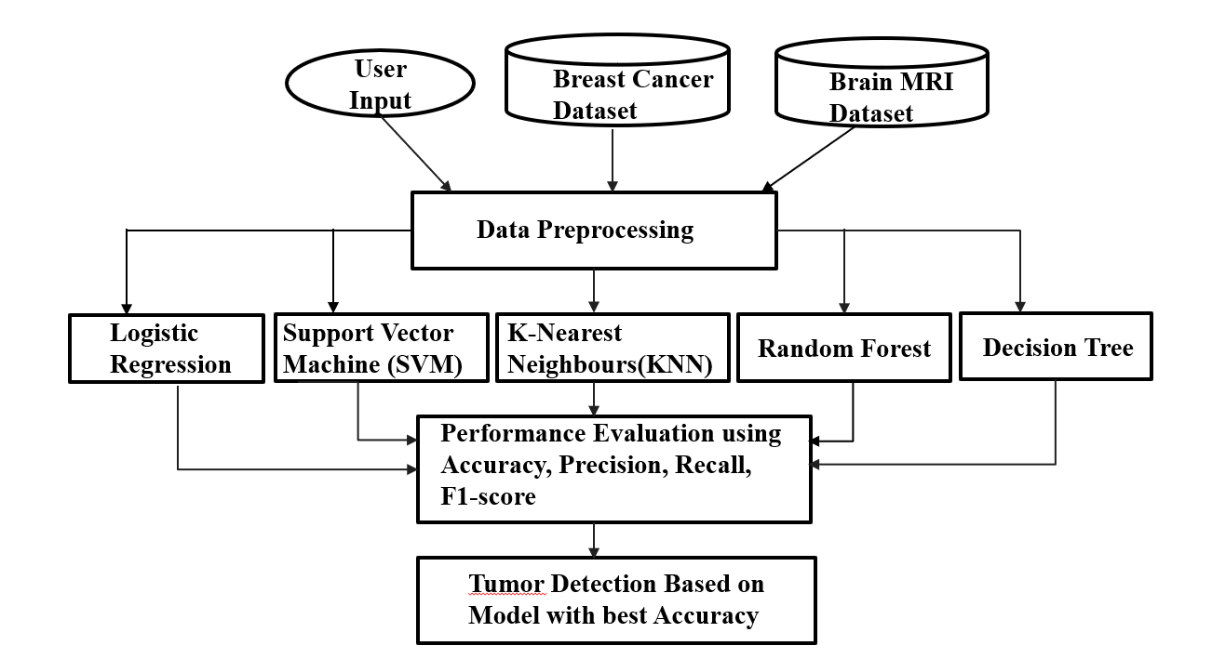 |  |  | Significance of the work  - Enables early and accurate tumour detection.  - Reduces human error in diagnosis.  - Supports data-driven medical decision-making.  - Improves consistency and efficiency in analysis.  - Helps identify the most reliable ML model for healthcare.
Dataset Details
- Breast Cancer Wisconsin dataset with 569 samples
- 30 numerical features describing tumour characteristics
- Binary classification: Benign and Malignant
Methodology:  - Dataset collection (Breast Cancer Wisconsin dataset).  - Data cleaning and preprocessing.  - Feature normalization using StandardScaler.  -Train-test split (80–20).  - Model training (LR, SVM, KNN, Decision Tree, Random Forest).  - Cross-validation (5-fold) for reliability.  - Hyperparameter tuning using GridSearchCV.  - Performance evaluation (accuracy, prec, recall, F1-score, ROC-AUC).  - Confusion matrix analysis for error detection. |  | Results and Analysis:  - Logistic Regression and SVM achieved highest accuracy (~98%).  - Both models showed balanced precision, recall, and F1-score.  - KNN and Random Forest gave moderate performance (~96%).  - Decision Tree showed lowest accuracy due to overfitting.  - Hyperparameter tuning gave slight performance improvement.  - Confusion matrix showed minimal false negatives (critical in medical cases).  - ROC-AUC score close to 1 indicates strong classification performance.  - Errors mainly due to overlapping feature values and limited dataset size.
Project Content’s Google Drive Link:

 | Name : M. Isaac Manohar  Roll No : 23241A6741  Email ID : misaacmanohar102@gmail.com  Phone no : 8639975947
 | Name : B. Sai Shiva Reddy  Roll No : 23245A6704  Email ID : saishivareddy850@gmail.com  Phone no : 7842792861
 | Name : K. Vishnu Vardhan  Roll No : 23241A6733  Email ID : vishnu10989@gmail.com  Phone no : 9030297483
Guide Details | Dr. Aruna Kumari

